**BANK LOAN REPORT QUERY DOCUMENT**

1. **BANK LOAN REPORT | SUMMARY**

**KPI’s:**

**Total Loan Applications**

SELECT COUNT(id) AS Total_Loan_Applications FROM bank_loan_data;

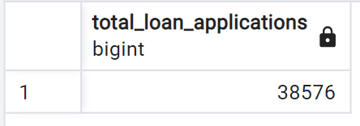

**MTD Loan Applications**

SELECT COUNT(id) AS MTD_Total_Applications FROM bank_loan_data

WHERE (SELECT EXTRACT(MONTH FROM issue_date)) = 12 AND (SELECT EXTRACT(YEAR FROM issue_date)) = 2021;

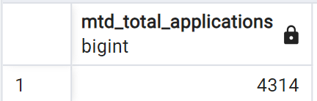

**PMTD Loan Applications**

SELECT COUNT(id) AS PMTD_Total_Applications FROM bank_loan_data

WHERE (SELECT EXTRACT(MONTH FROM issue_date)) = 11 AND (SELECT EXTRACT(YEAR FROM issue_date)) = 2021;

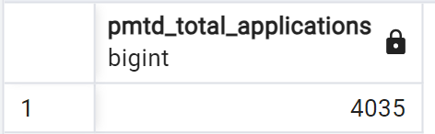

**Total Funded Amount**

SELECT SUM(loan_amount) AS Total_Funded_Amount FROM bank_loan_data;

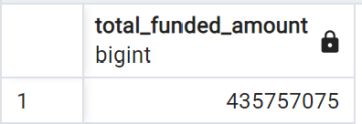

**MTD Total Funded Amount**

SELECT SUM(loan_amount) AS MTD_Total_Funded_Amount FROM bank_loan_data

WHERE (SELECT EXTRACT(MONTH FROM issue_date)) = 12 AND (SELECT EXTRACT(YEAR FROM issue_date)) = 2021;

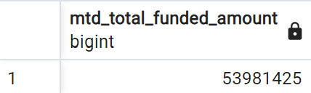

**PMTD Total Funded Amount**

SELECT SUM(loan_amount) AS PMTD_Total_Funded_Amount FROM bank_loan_data

WHERE (SELECT EXTRACT(MONTH FROM issue_date)) = 11 AND (SELECT EXTRACT(YEAR FROM issue_date)) = 2021;

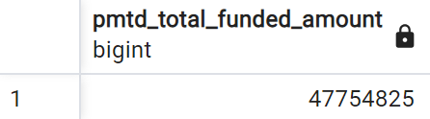

**Total Amount Received**

WHERE (SELECT EXTRACT(MONTH FROM issue_date)) = 11 AND (SELECT EXTRACT(YEAR FROM issue_date)) = 2021;

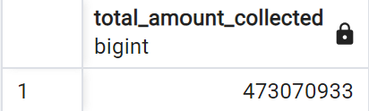

**MTD Total Amount Received**

SELECT SUM(total_payment) AS MTD_Total_Amount_Collected FROM bank_loan_data

WHERE (SELECT EXTRACT(MONTH FROM issue_date)) = 12 AND (SELECT EXTRACT(YEAR FROM issue_date)) = 2021;

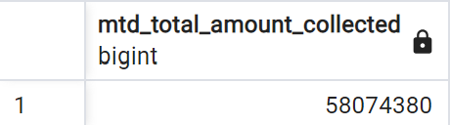

**PMTD Total Amount Received**

SELECT SUM(total_payment) AS MTD_Total_Amount_Collected FROM bank_loan_data

WHERE (SELECT EXTRACT(MONTH FROM issue_date)) = 11 AND (SELECT EXTRACT(YEAR FROM issue_date)) = 2021;

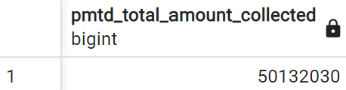

**Average Interest Rate**

SELECT AVG(int_rate)*100 AS Avg_Int_Rate FROM bank_loan_data;

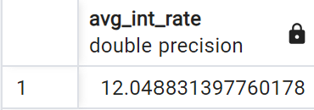

**MTD Average Interest**

SELECT AVG(int_rate)*100 AS MTD_Avg_Int_Rate FROM bank_loan_data

WHERE (SELECT EXTRACT(MONTH FROM issue_date)) = 12 AND (SELECT EXTRACT(YEAR FROM issue_date)) = 2021;  
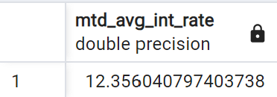

**PMTD Average Interest**

SELECT AVG(int_rate)*100 AS MTD_Avg_Int_Rate FROM bank_loan_data

WHERE (SELECT EXTRACT(MONTH FROM issue_date)) = 11 AND (SELECT EXTRACT(YEAR FROM issue_date)) = 2021;

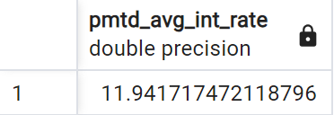

**Avg DTI**

SELECT AVG(dti)*100 AS Avg_DTI FROM bank_loan_data;

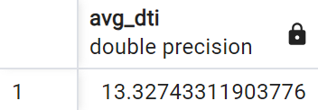

**MTD Avg DTI**

SELECT AVG(dti)*100 AS MTD_Avg_DTI FROM bank_loan_data

WHERE (SELECT EXTRACT(MONTH FROM issue_date)) = 12 AND (SELECT EXTRACT(YEAR FROM issue_date)) = 2021;

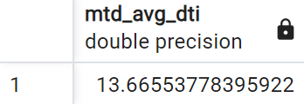

**PMTD Avg DTI**

SELECT AVG(dti)*100 AS PMTD_Avg_DTI FROM bank_loan_data

WHERE (SELECT EXTRACT(MONTH FROM issue_date)) = 11 AND (SELECT EXTRACT(YEAR FROM issue_date)) = 2021;

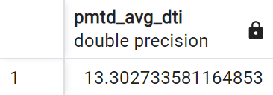

**GOOD LOAN ISSUED**

**Good Loan Percentage**

SELECT

(COUNT(CASE WHEN loan_status='Fully Paid' OR loan_status ='Current' THEN id END)*100)

/

(COUNT(id)) AS Good_loan_percentage

FROM bank_loan_data;

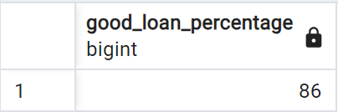

**Good Loan Applications**

SELECT COUNT(id) FROM bank_loan_data

WHERE loan_status = 'Fully Paid' OR loan_status = 'Current';

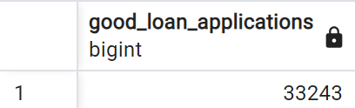

**Good Loan Funded Amount**

SELECT SUM(loan_amount) as Good_loan_Funded_amount FROM bank_loan_data

WHERE loan_status = 'Fully Paid' OR loan_status = 'Current';

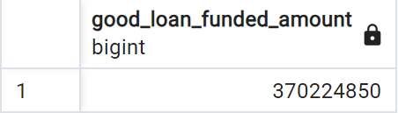

**Good Loan Amount Received**

SELECT SUM(total_payment) as Good_loan_Recieved_Amount FROM bank_loan_data

WHERE loan_status = 'Fully Paid' OR loan_status = 'Current';

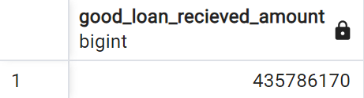

**BAD LOAN ISSUED**

**Bad Loan Percentage**

SELECT

(COUNT(CASE WHEN loan_status='Charged Off' THEN id END)*100)

/

(COUNT(id)) AS Bad_loan_percentage

FROM bank_loan_data;

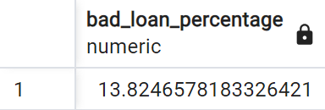

**Bad Loan Applications**

SELECT COUNT(id) AS Bad_Loan_Applications FROM bank_loan_data

WHERE loan_status = 'Charged Off'

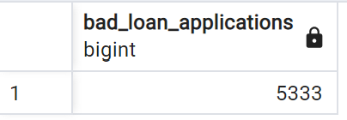

**Bad Loan Funded Amount**

SELECT SUM(loan_amount) AS Bad_Loan_Funded_amount FROM bank_loan_data

WHERE loan_status = 'Charged Off'

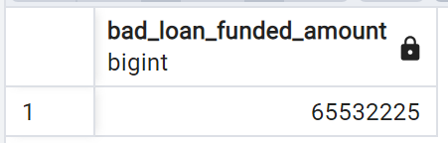

**Bad Loan Amount Received**

SELECT SUM(total_payment) AS Bad_Loan_amount_received FROM bank_loan_data

WHERE loan_status = 'Charged Off'

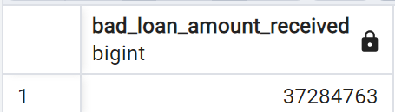

**LOAN STATUS**

SELECT

loan_status,

COUNT(id) AS LoanCount,

SUM(total_payment) AS Total_Amount_Received,

SUM(loan_amount) AS Total_Funded_Amount,

AVG(int_rate * 100) AS Interest_Rate,

AVG(dti * 100) AS DTI

FROM

bank_loan_data

GROUP BY

loan_status

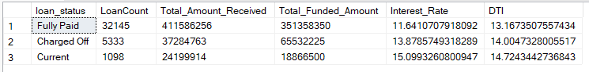

SELECT

loan_status,

SUM(total_payment) AS MTD_Total_Amount_Received,

SUM(loan_amount) AS MTD_Total_Funded_Amount

FROM bank_loan_data

WHERE MONTH(issue_date) = 12

GROUP BY loan_status

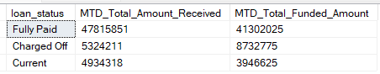

1. **BANK LOAN REPORT | OVERVIEW**

**MONTH**

SELECT

(SELECT EXTRACT(MONTH FROM issue_date)) AS Month_Number,

(SELECT TO_CHAR(issue_date, 'Month')) AS Month_name,

COUNT(id) AS Total_Loan_Applications,

SUM(loan_amount) AS Total_Funded_Amount,

SUM(total_payment) AS Total_Amount_Received

FROM bank_loan_data

GROUP BY Month_Number, Month_name

ORDER BY Month_Number;

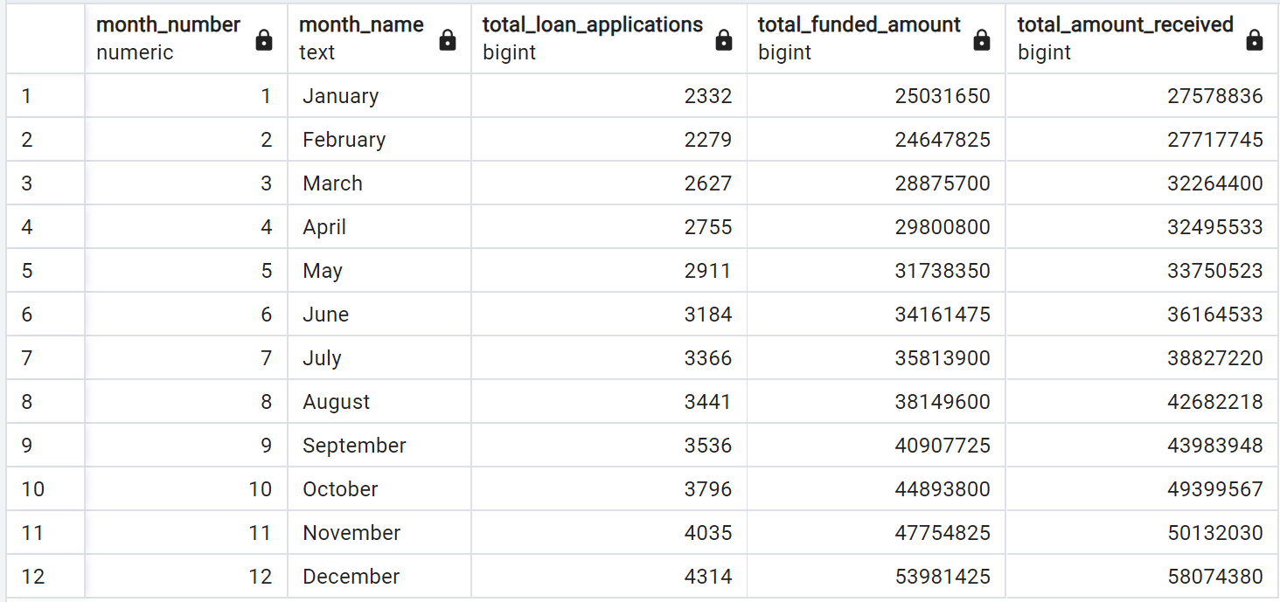

**STATE**

SELECT

address_state AS State,

COUNT(id) AS Total_Loan_Applications,

SUM(loan_amount) AS Total_Funded_Amount,

SUM(total_payment) AS Total_Amount_Received

FROM bank_loan_data

GROUP BY address_state

ORDER BY address_state;

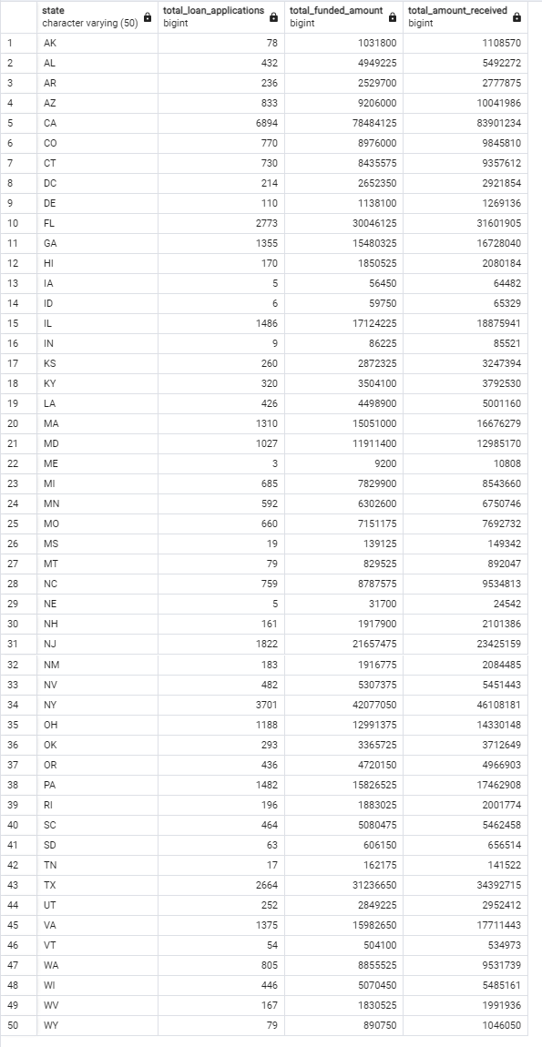

**TERM**

SELECT

term AS Term,

COUNT(id) AS Total_Loan_Applications,

SUM(loan_amount) AS Total_Funded_Amount,

SUM(total_payment) AS Total_Amount_Received

FROM bank_loan_data

GROUP BY term

ORDER BY term;

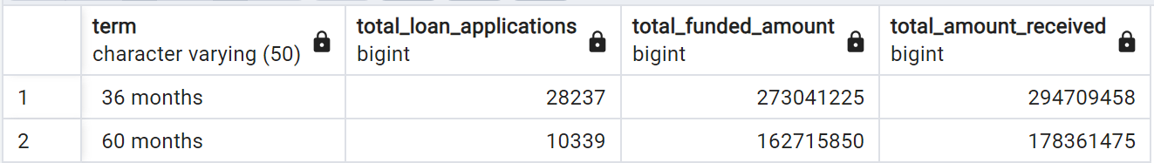

**EMPLOYEE LENGTH**

SELECT

emp_length AS Employee_Length,

COUNT(id) AS Total_Loan_Applications,

SUM(loan_amount) AS Total_Funded_Amount,

SUM(total_payment) AS Total_Amount_Received

FROM bank_loan_data

GROUP BY emp_length

ORDER BY emp_length;

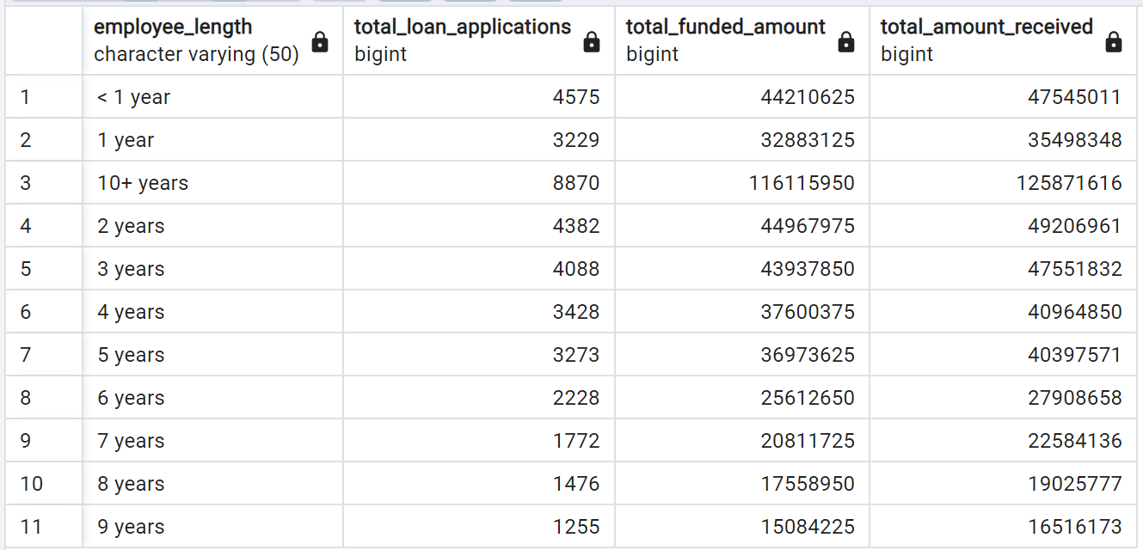

**PURPOSE**

SELECT

purpose AS PURPOSE,

COUNT(id) AS Total_Loan_Applications,

SUM(loan_amount) AS Total_Funded_Amount,

SUM(total_payment) AS Total_Amount_Received

FROM bank_loan_data

GROUP BY purpose

ORDER BY purpose;

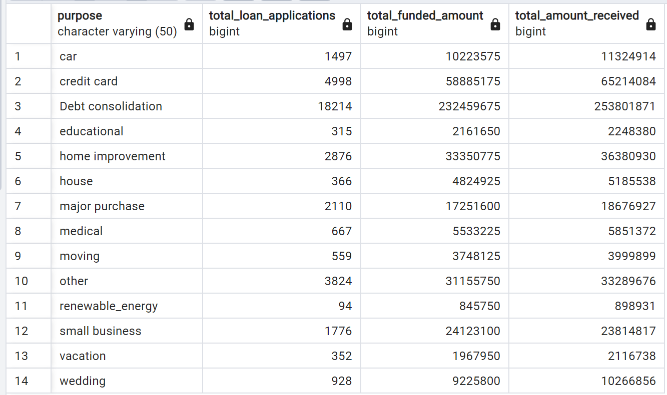

**HOME OWNERSHIP**

SELECT

home_ownership AS Home_Ownership,

COUNT(id) AS Total_Loan_Applications,

SUM(loan_amount) AS Total_Funded_Amount,

SUM(total_payment) AS Total_Amount_Received

FROM bank_loan_data

GROUP BY home_ownership

ORDER BY home_ownership;

